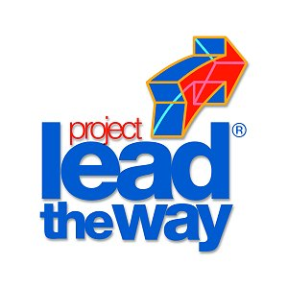
Project 2.2.4 - You’re The Expert

Purpose
Basic background information is the foundation for more indepth research. At this point in your research project, it is important to compile the information that has been collected in a concise format.

Equipment
- Engineer’s notebook
- Computer with Microsoft Word
- Internet access
- Research materials
- Printer

Procedure
In this project, your team will create a brochure that can be used as a tool to explain to others your project’s focus and why you think it is worth pursuing. It can also be used to secure financial backing from organizations and businesses in your area.

Using the word processing software available in the computer lab, prepare a tri-fold brochure that will explain the topics listed below:
- Project Title
- Choose a simple title that will easily describe your project.
- Pictures or Clip Art
- Include three images that are easy on the eyes. Keep the scale of the brochure in mind when selecting the images.
- Personal Information
- Your full name
- School name, mailing address, teacher’s name, school phone number, email address
- Problem Statement
- Using your best grammar, state the problem you have found and give a handful of basic facts.
- Add statistics you may have obtained.
- Make a point that the problem needs to be solved.
- Add basic background or history information that the general observer would need.
- Key Words
- List 25 key words or terms on the back of the brochure to help guide others in understanding your team’s project.
- Five Associations, Organizations, and Societies connected to your problem
- Compile a list of the experts you identified in Project 2.2.1 Who are the Experts.
- List their names and website information or physical addresses.

When your team is finished, submit the brochure to your teacher for evaluation.

Conclusion
- What was the purpose of the key words listed on your team’s brochure?

- What skills did you use when creating your team’s brochure that can be used as a future engineer?

